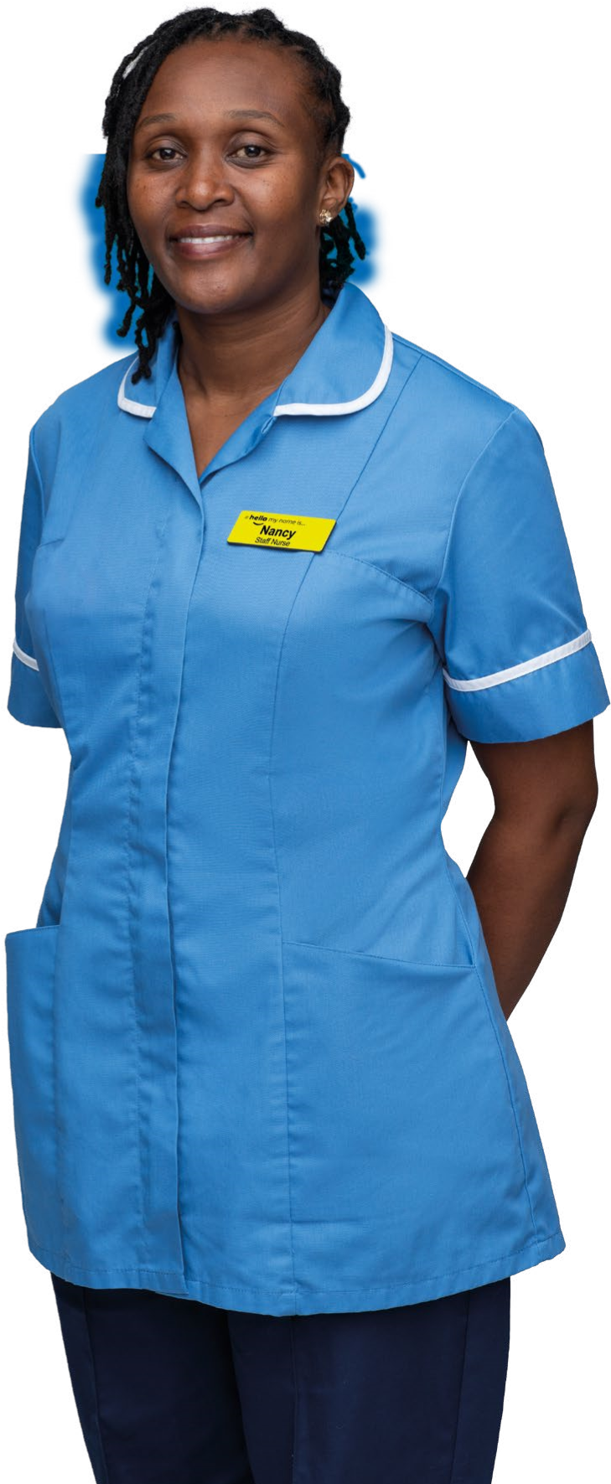
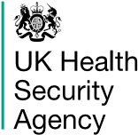
www.
nhs.u
k
Some important
information from
the NHS to help
you stay well

this winter
We’re here to
help you stay
well this winter
Nancy Mutai, Staff Nurse

Stay well this winter
If you’re worried about your health, don’t delay, your NHS wants to see you – help us help you get the care you need this winter.
Winter conditions can be bad for our health, especially for people aged 65 or older, and people with long-term conditions such as heart or kidney disease, COPD (including emphysema and chronic bronchitis), asthma or diabetes.
Being cold can raise the risk of increased blood pressure, heart attacks and strokes.
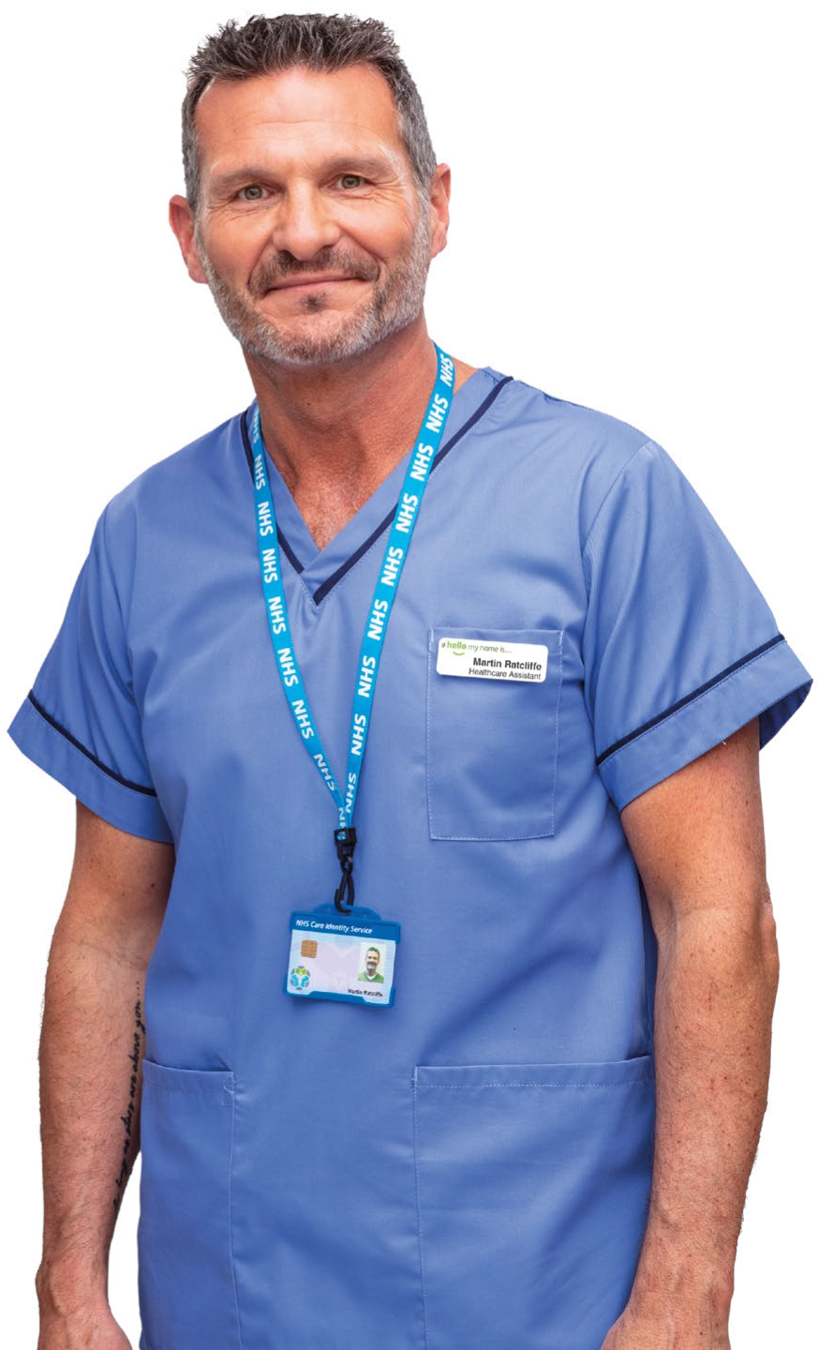
The cold and damp weather, ice, snow and high winds can all aggravate any existing health problems and make us more vulnerable to respiratory winter illnesses. But there are lots of things you can do to stay well this winter.
Martin Ratcliffe, Healthcare Assistant

Make sure you get your COVID-19 booster and flu vaccinations
All those who are at greater risk from the COVID-19 and flu viruses should take the extra protection offered by vaccination this winter.
If you are aged 50 or over, or pregnant, or have a weakened immune system or long-term health condition, you will be eligible to receive your free COVID-19 booster and flu vaccinations.
COVID-19 and flu can be serious for these groups and flu can lead to serious complications such as bronchitis and pneumonia, and it can be deadly. So getting your flu and COVID-19 vaccines are two of the most important things you can do to keep yourself and others around you safe this winter.
The NHS will email or text you when it’s your turn to be invited, and people can book their COVID-19 booster vaccine using the National Booking Service or by calling 119, or you can find a local vaccination walk-in site. 119 is also available by textphone on 18001 119 and the NHS 119 BSL interpreter service at: signvideo.co.uk/nhs119
If you are pregnant you are eligible for a free flu vaccination at any time in your pregnancy; ask your GP practice, pharmacist or midwife. And if you are the main carer of an older or disabled person, you may also be eligible for the free flu vaccine.
If you have young children or grandchildren they may also be eligible for a free flu nasal spray vaccination.
Speak to your GP practice or pharmacist. You can also find more information at www.nhs.uk/fluvaccine
Also, don’t forget that if you’re aged 65 or over, or have certain health conditions, you are eligible for the pneumococcal vaccine, which will help protect you from pneumococcal diseases such as pneumonia. Ask your GP practice.
Suspect you have COVID-19?
Try to stay at home and avoid contact with other people if you have any symptoms of COVID-19 and have a high temperature, or you do not feel well enough to go to work or do your normal activities.
You should avoid being in close contact with people at higher risk from COVID-19.
This is particularly important if their immune system means they’re at higher risk of serious illness from COVID-19, even if they’ve had a COVID-19 vaccine.
When to seek medical advice
Go to 111.nhs.uk, call 111 or call your GP surgery if:
- You’re worried about your symptoms
- Your symptoms get worse
In an emergency, go to A&E immediately or call 999.

How to avoid passing COVID-19 on to others
- Try and stay at home if you can – this helps reduce the number of people you have contact with.
- Avoid contact with people at higher risk from COVID-19 for 10 days, especially if their immune system means they’re at higher risk of serious illness from COVID-19.
- Let people who need to come into your home know that you’ve tested positive or have symptoms.
- You may wish to ask friends, family or neighbours to get food or other essentials for you.
- If you have visitors, it can help stop the spread of germs to ventilate the room for a few minutes before and after they arrive. You might be more comfortable leaving the window open during their visit, if it’s not too cold.

Treatments for COVID-19
The NHS offers treatments to people with COVID-19 who are at the highest risk of becoming seriously ill, for example, people whose immune system means they are at higher risk of serious illness from COVID-19.
Anyone eligible for treatment will have received in the spring, or more recently, an initial pack of COVID-19 lateral flow tests to use if they develop symptoms, and a letter from UKHSA confirming how and when to use these.
For more information, visit: www.nhs.uk/CoronavirusTreatments
If you are eligible for COVID-19 treatments, you can order a further pack of free rapid lateral flow tests to keep at home to use when you develop symptoms, on GOV.UK or by calling 119. If you have any symptoms of COVID-19, take a test as soon as possible and report your result on GOV.UK or 119.
The NHS will usually call you about treatment if you report a positive test result.
If you have not been contacted within 24 hours of your positive test, but you think that you may be eligible for COVID-19 treatments, call your GP surgery, specialist or 111.

Keep warm
Keeping warm over the winter months can help to prevent colds, flu and more serious health problems such as heart attacks, strokes, pneumonia and depression.
Heat your home to a temperature that’s comfortable for you. If you can, this should be at least 18°C in the rooms that you regularly use, such as your living room and bedroom. This is particularly important if you have a pre-existing medical condition. You should also keep your bedroom windows closed at night.
Make sure you’re receiving all the help that you’re entitled to. There are grants, benefits and sources of advice available to make your home more energy efficient, improve your heating or help with bills. Visit www.simpleenergyadvice.org.uk and www.gov.uk/browse/benefits/heating for further information.
And check your heating and cooking appliances are safe. Contact a Gas Safe registered engineer to make sure they’re operating properly. Visit www.gassaferegister.co.uk and www.nationalfirechiefs.org.uk

Fire safety at home
Most fires in the home start accidentally. Understanding why fires start and what you can do to prevent them will help keep you, other people and your property safe.
You can complete an online home fire safety check yourself. After answering a few questions about you and your home, it will provide fire safety advice specific to you and tips on how to keep you and your household safe from fire.
For your free online home fire safety check, visit
www.ohfsc.co.uk

Keep active
There’s strong evidence that people who are active have a lower risk of heart disease, stroke, type 2 diabetes, some cancers, depression and dementia. Regular exercise can help improve your mental health, reduce the risk of falling and can be beneficial for recovery if you do get ill.
Try to reduce the amount of time you spend sitting down during the day. Break up your time spent being inactive by walking around your home or standing up from your chair during TV advert breaks or when you’re on the phone.
There are many activities you could do at home, such as walking up and down stairs, dancing, gardening, housework, or taking part in online fitness classes.
It doesn’t matter what you do, as long as it’s something you enjoy and keeps you moving. Don’t do anything that doesn’t feel comfortable and trust your instincts about your own limits. Stop if you are feeling any pain or lightheaded and stay hydrated.


For tips on keeping active go to www.nhs.uk/keepactive or have a look at www.ageuk.org.uk

Mental health support
We all feel down from time to time, no matter our age. But if you’ve not been feeling yourself for a while, talking therapy could help you feel better.
Speak to your GP practice about NHS Talking Therapies if you’re feeling anxious, depressed, or struggling to cope. Your GP is there to help you – physically and mentally – and can refer you to the right service.

Joseph Larkai, Pharmacist
You can also self refer by visiting: www.nhs.uk/iaptservices
If you or a loved one are experiencing a mental health crisis, you can call your local NHS mental health helpline for
24-hour advice and support: www.nhs.uk/urgentmentalhealth

Check your medicine cabinet
Ask your pharmacist what medicines should be in your cabinet to help you and your family this winter.
Many over-the-counter medicines (including paracetamol and ibuprofen) are available to relieve symptoms of common winter illnesses such as colds, sinusitis or painful middle ear infection (earache). Your pharmacist can help if you need any advice.
To manage winter illness symptoms at home, you should keep warm, rest, drink plenty of fluids, have at least one hot meal a day to keep your energy levels up and use over-thecounter medicines to help give relief.
For more information search ‘medicines’ on www.nhs.uk

Handwashing
Washing your hands with soap and water is one of the easiest ways to protect yourself and others from illnesses such as food poisoning, diarrhoea, flu and COVID-19.
Wash your hands thoroughly for the amount of time it takes to sing “Happy Birthday” twice (around 20 seconds).
You should wash your hands:
- once you get home, or into work
- after using the toilet or changing a nappy
- before and after handling raw foods like meat and vegetables
- before eating or handling food
- after blowing your nose, sneezing or coughing
- before and after treating a cut or wound
- after touching animals, including pets, their food and after cleaning their cages.

Washing your hands properly removes dirt, viruses and bacteria to stop them spreading to other people and objects. If you do not have immediate access to soap and water then use alcohol-based handrub.
For more information go to
www.nhs.uk/handwashing

Prescriptions
Make sure you get your prescription medicines before your pharmacy or GP practice closes for holidays.
And, if you’ve been prescribed antibiotics or any other medication, make sure you take them as directed.

Kiera Whitehead-Elliott Pharmacy Technician
Don’t go to a pharmacy if you have symptoms of COVID-19 or are self-isolating. You can order prescriptions via GP or pharmacy websites, by calling them, or via NHS-approved apps. Ask a friend, relative or volunteer to collect medicines for you.
A list of NHS-approved apps is here: www.nhs.uk/approvedproviders
You can also order your repeat prescriptions via the NHS App, as well as make GP appointments. The NHS App is available on the App Store and on Google Play. For more information visit www.nhs.uk/nhsapp

Look out for other people
Remember that other people, such as older neighbours, friends and family members, may need a bit of extra help over the winter. There’s a lot you can do to help people who are more frail than you.
Icy pavements and roads can be very slippery, and cold weather can stop people from getting out and about.
Keep in touch with your friends, neighbours and family and ask if they need any practical help, or if they’re feeling under the weather.
Make sure they’re stocked up with enough food supplies for a few days, in case they can’t go out. If they do need to go out in the cold, encourage them to wear shoes with a good grip and a scarf around the mouth to protect them from the cold air, and to reduce their risk of chest infections.
And make sure they get any prescription medicines before the holiday period starts and if bad weather is forecast.

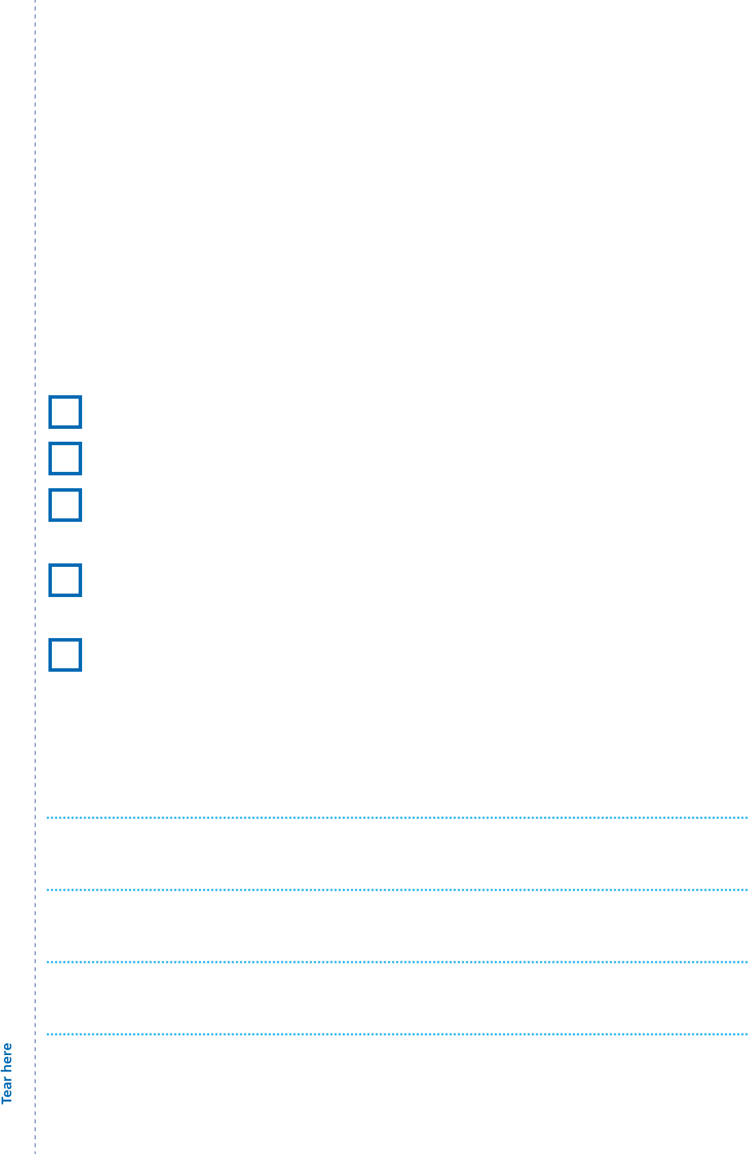
If they need help over the holiday period when the GP practice or pharmacy is closed or they’re not sure what to do, NHS 111 can help. The service is available online at 111.nhs.uk and also by phone. By answering questions about their health problem they will be told what to do and where to go. You can also find information at www.nhs.uk
Five things we recommend you do:
Make sure you get your flu vaccination.
Come forward for your COVID-19 booster when offered.
Take advantage of financial schemes and discounts to help you pay for heating.
Contact NHS 111 online or by phone if you are worried about any symptoms.
Look out for other people who may need a bit of extra help over the winter.
Write down your surgery and local pharmacy numbers here:

Where to go for the right medical help
Dial 999 for

life-threatening emergencies
If you need medical help fast or think you need to go to an Emergency Department (A&E) use NHS 111 first – online or by phone* –
111.nhs.uk to get clinical advice or direction to the most appropriate services for treatment
GP For all other health needs, contact your pharmacy
Pharmacy or GP practice. You can also access NHS advice www.nhs.uk and information at www.nhs.uk
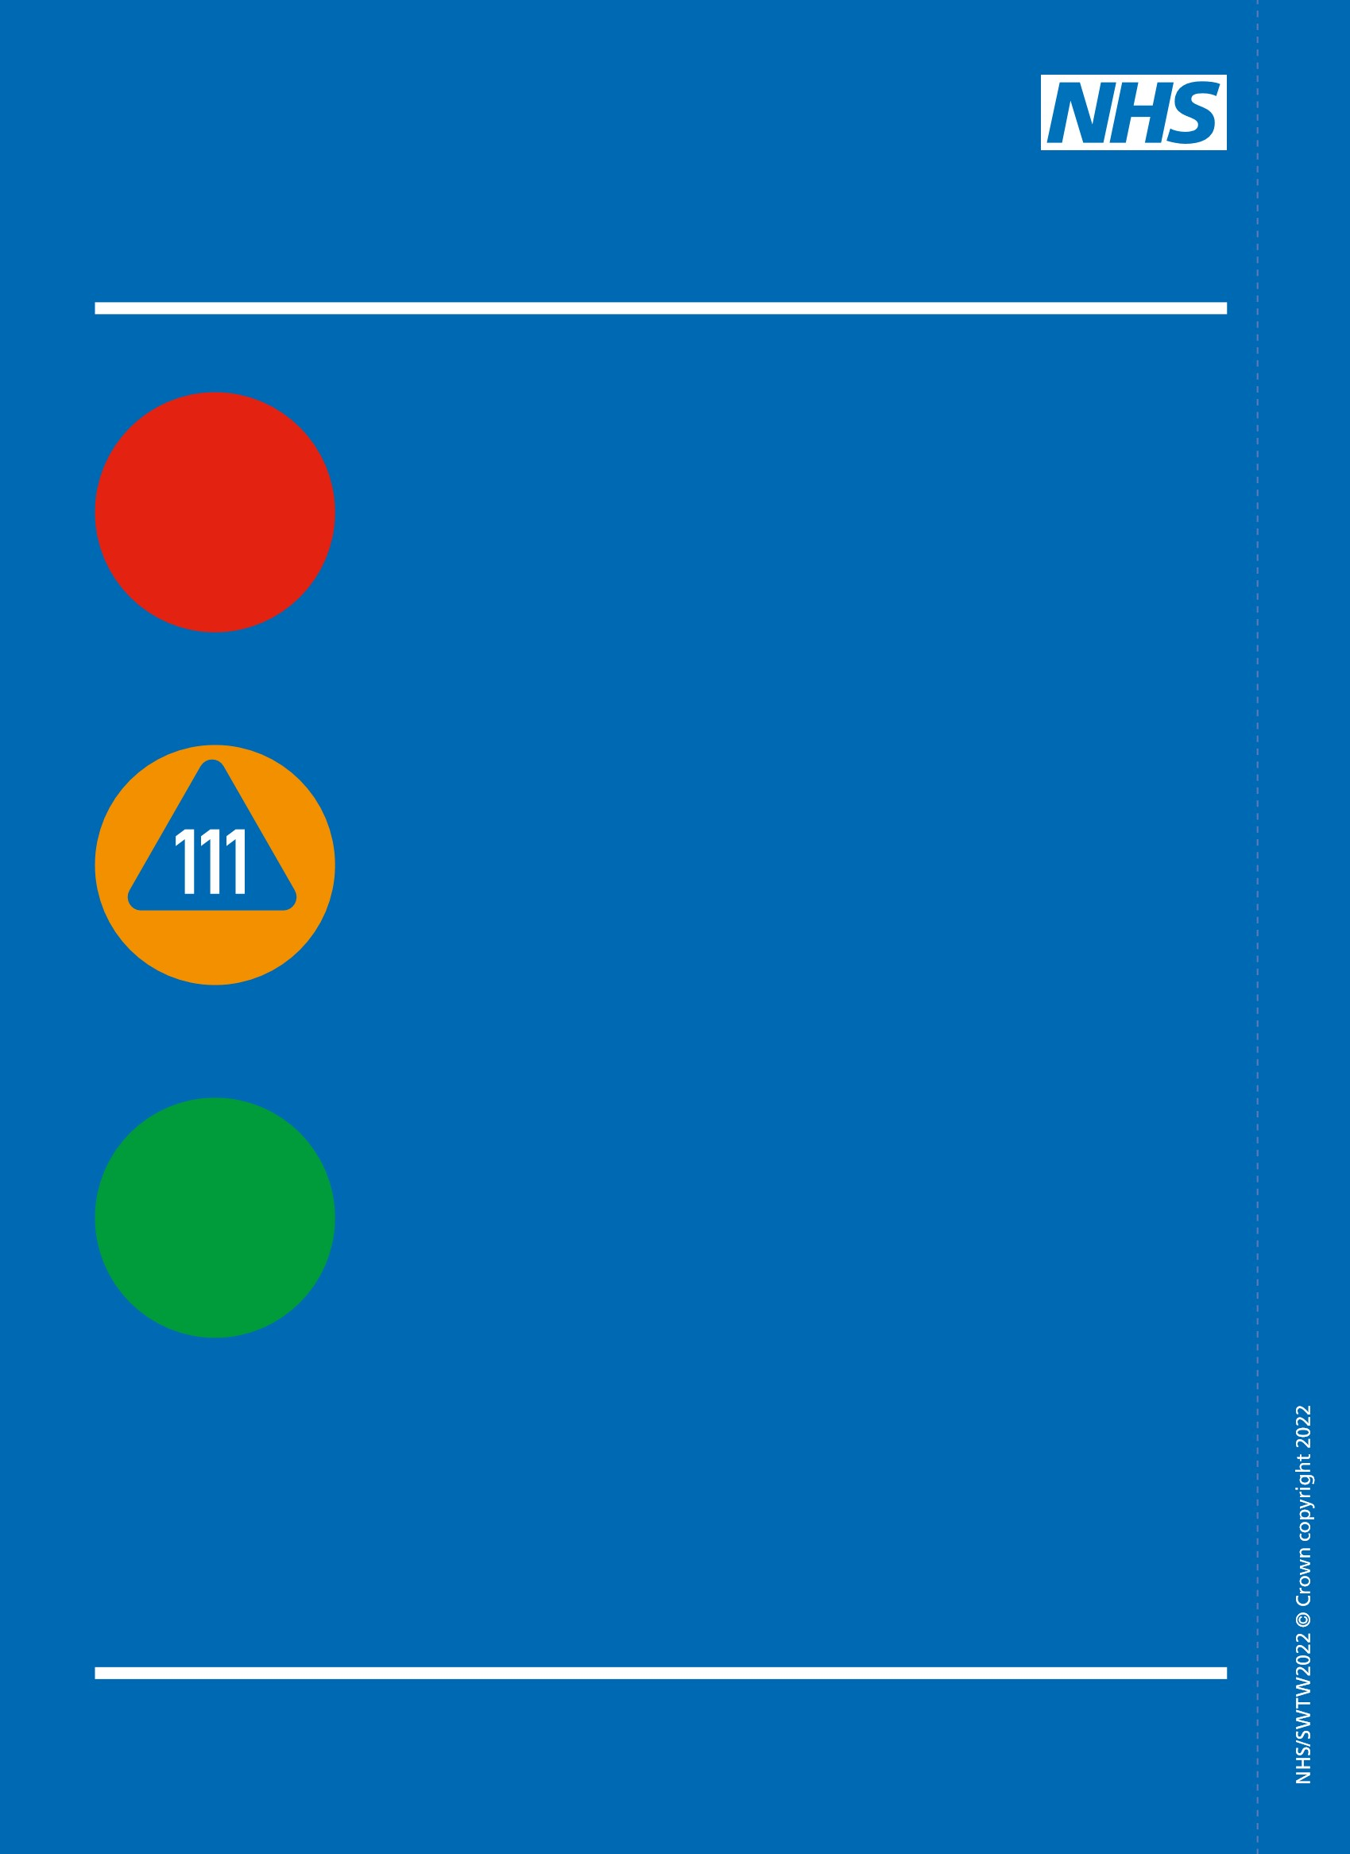
*If you have difficulties communicating or hearing, you can use the NHS 111 British Sign Language (BSL) interpreter service via www.nhs.uk/111 or call 18001 111 on a textphone.
This leaflet is available in alternative formats at www.nhs.uk/staywell Email partnerships@phe.gov.uk for braille copies.

